MACH4METAL

metalworking machinery
Transito 21,
6909 DA BABBERICH, Netherlands
Tel. + 31 (0)316 – 247123
Fax. + 31 (0)316 - 247956

Bank No : 66.52.13.883
IBAN : NL33 INGB 0665 2138 83
BIC : INGBNL2A

WMW DKZ 2000 VTL Ø 2000
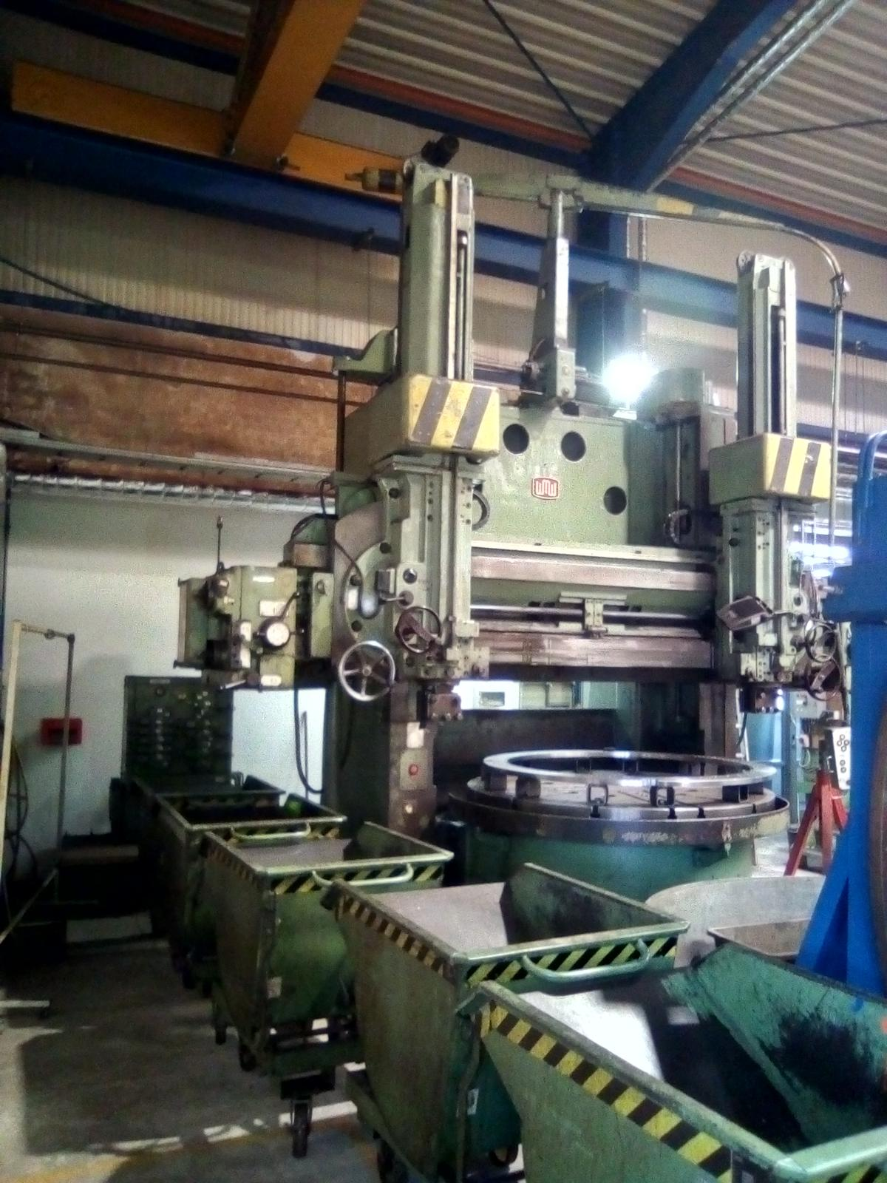
- Make : WMW Germany
- Type : DKZ 2000 x 1250 B
- Serial : 6964984
- YOP : 1978

- Table diameter Ø : 1800
- Max. swing Ø : 2000
- Max. turning height : 1250

- Max. work piece weight : 6000
- Cross rail adjustment : 1150
- Distance face plate tool : 1325

- Table speed range Rpm : 50
- Table motor power kW : 35

- RAM horizontal travel : 700
- RAM vertical travel : 700
- RAM Dimension : 280 x 280
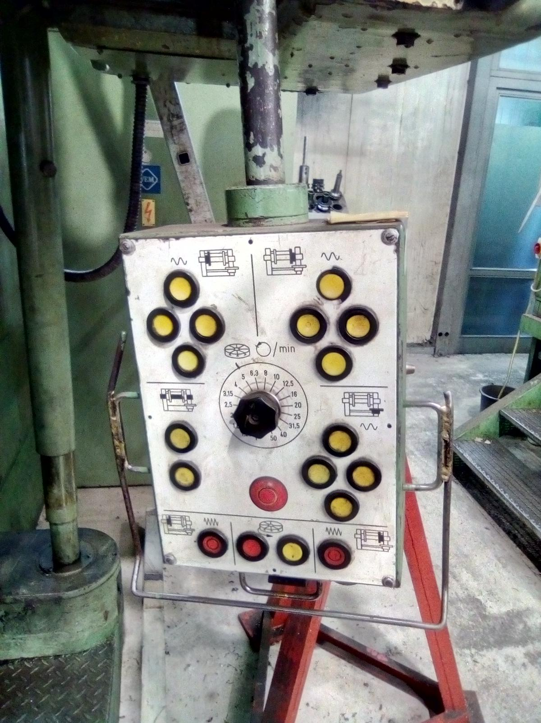

- Crossrail vertical travel :
- Column movement sliding :

- In 2006 rebuild at TOS KURIM
- New electric cabinet
- New cable / engines / measure / 840D

- Length : 4.100
- Width : 5.300
- Height : 4.800
- Weight : 30.300

- Accu Rite Digital readout
- 4 Jaws on chuck
Please Note: The above information has been obtained to the best of our ability and belief from, and from the manufacturers where possible. It is given in good faith, but its accuracy can not be guaranteed. Accordingly, it will not form a representation or constitute contractual terms. We advise you to check any vital details

